**PROPOSED E-INVOICING SYSTEM**

The GST Council has approved introduction of ‘E-invoicing’ or ‘electronic invoicing’ in a phased manner for reporting of business to business (B2B) invoices to GST System, starting from 1st January 2020 on voluntary basis. Since there was no standard for e-invoice existing in the country, standard for the same has been finalized after consultation with trade/industry bodies as well as ICAI after keeping the draft in public place. Having a standard is a must to ensure complete inter-operability of e-invoices across the entire GST eco-system so that e-invoices generated by one software can be read by any other software, thereby eliminating the need of fresh data entry – which is a norm and standard expectation today. The machine readability and uniform interpretation is the key objective. This is also important for reporting the details to GST System as part of Return. Apart from the GST System, adoption of a standard will also ensure that an e-invoice shared by a seller with his buyer or bank or agent or any other player in the whole business eco-system can be read by machines and obviate and hence eliminate data entry errors.

The GST Council approved the standard of e-invoice in its 37th meeting held on 20th Sept 2019 and the same along with schema has been published on GST portal. Standards are generally abstruse and thus an explanation document is required to present the same in common man’s language. Also, there are lot of myth or misconception about e-Invoice. The present document is an attempt to explain the concept of e-invoice, how it operates and basics of standards. It also contains FAQs which answer the questions raised by people who responded to the draft e-invoice standard used for public consultation. It is expected that the document will also be useful for the taxpayers, tax consultants and the software companies to adopt the designed standard.

**A. What is e-invoice?**

If an invoice is generated by a software on the computer or Point of Sales (PoS) machine then does it become an e-invoice? Is e-invoice as a system where taxpayers can generate the invoices centrally? Many such questions are raised when e-invoice gets discussed.

E-invoice does not mean generation of invoices from a central portal of tax department, as any such centralization will bring unnecessary restriction on the way trade is conducted. In fact, taxpayers have different requirements and expectation, which can’t be met from one software generating e-invoices from a portal for the whole country. Invoice generated by each software may look more or less same, however, they can’t be understood by another computer system even though business users understand them fully. For example, an Invoice generated by SAP system cannot be read by a machine which is using ‘Tally’ system. Likewise there are hundreds of accounting/billing software which generate invoices but they all use their own formats to store information electronically and data on such invoices can’t be understood by the GST System if reported in their respective formats. Hence a need was felt to standardize the format in which electronic data of an Invoice will be shared with others to ensure there is interoperability of the data. The adoption of standards will in no way impact the way user would see the physical (printed) invoice or electronic (ex pdf version) invoice. All these software would adopt the new e-Invoice standard wherein they would re-align their data access and retrieval in the standard format. However, users of the software would not find any change since they would continue to see the physical or electronic (PDF/Excel) output of the invoices in the same manner as it existed before incorporation of e-Invoice standard in the software. Thus the taxpayer would continue to use his accounting system/ERP or excel based tools or any such tool for creating the electronic invoice as s/he is using today.

To help small taxpayers adopt e-invoice system, GSTN has empaneled eight accounting & billing software which provide basic accounting and billing system free of cost to small taxpayers. Those small taxpayers who do not have accounting software today, can use one of the empaneled software products, which come in both flavors, online (cloud based) as well as offline (installed on the computer system of the user).

**B. e-Invoice and Tax Department**

The e-invoice system being implemented by tax departments across the globe consists of two important parts namely,

a) Generation of invoice in a standard format so that invoice generated on one system can be read by another system.

b) Reporting of e-invoice to a central system.

The basic aim behind adoption of e-invoice system by tax departments is ability to pre-populate the return and to reduce the reconciliation problems. Huge increase in technology sophistication, increased penetration of Internet along with availability of computer systems at reasonable cost has made this journey possible and hence more than 60 countries are in the process of adopting the e-invoice.

GST Council has given the responsibility to design the standard of e-invoice and update the same from time to time to GSTN which is the custodian of Returns and invoices contained in the same. Adoption of e-invoice by GST System is not only part of Tax reform but also a Business reform as it make the e-invoices completely inter-operable eliminating transcription and other errors.

**C. Other derived benefits of introduction of e-invoice from GST perspective**

|  |  |
| --- | --- |
| **Objectives** | **Outcome** |
| **Better taxpayer services** | * One time reporting on B2B invoice data in the form it is generated to reduce reporting in multiple formats (one for GSTR-1 and the other for e-way bill). * To generate Sales and purchase register (ANX-1 and ANX-2) from this data to keep the Return (RET-1 etc.) ready for filing under New Return. e-Way bill can also be generated using e-Invoice data * It will become part of the business process of the taxpayer * Substantial reduction in input credit verification issues as same data will get reported to tax department as well to buyer in his inward supply (purchase) register. * On receipt of info thru GST System as buyer can do reconciliation with his Purchase Order and accept/reject in time under New Return |
| **Reduction of tax evasion** | * Complete trail of B2B invoices * System level matching of input credit and output tax |
| **Efficiency in tax administration** | * Elimination of fake invoices |

Generation of e-invoice will be the responsibility of the taxpayer who will be required to report the same to Invoice Registration Portal (IRP) of GST, which in turn will generate a unique Invoice Reference Number (IRN) and digitally sign the e-invoice and also generate a QR code. The QR Code will contain vital parameters of the e-invoice and return the same to the taxpayer who generated the document in first place. The IRP will also send the signed e-invoice to the recipient of the document on the email provided in the e-invoice.

***Note:*** *To begin with, there will be only one IRP, but more IRPs will be added to provide higher availability, redundancy, speed and a diversified and distributed service to tax payers with a choice.*

**D. What type of documents are to be reported to GST System?**

While the word invoice is used in the name of e-invoice, it covers other documents that will be required to be reported to IRP by the creator of the document:

1. Invoice by Supplier
2. Credit Note by Supplier
3. Debit Note by Supplier
4. Any other document as required by law to be reported by the creator of the document

**E. What will be the workflow involved?**

The flow of the e-invoice generation, registration and receipt of confirmation can be logically divided into two major parts.

1. The first part being the interaction between the business (supplier in case of invoice) and the Invoice Registration Portal (IRP).
2. 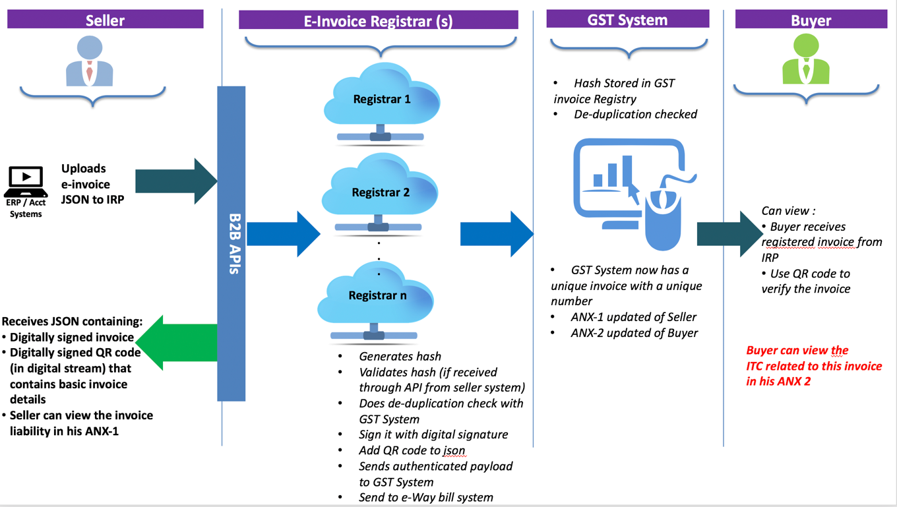The second part is the interaction between the IRP and the GST/E-Way Bill Systems and the Buyer.

The two parts of the workflow are depicted diagrammatically below and followed up with an explanation of the steps involved. As the process evolves and system matures the same would be intercommunicated between buyer’s software and seller’s software, banking systems etc.

**Part A: Flow from Supplier (commonly known as seller) to IRP**.

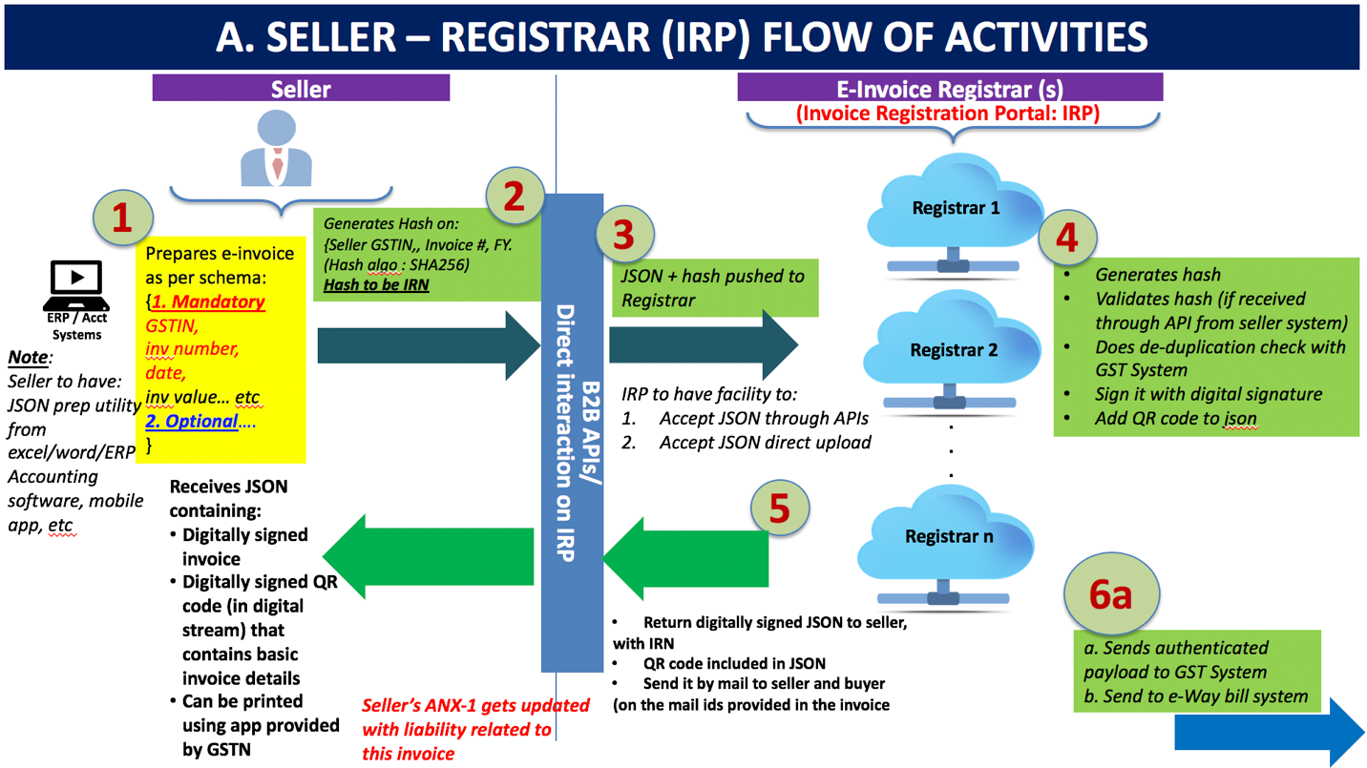**Step 1** is the generation of the invoice by the seller in his own accounting or billing system (it can be any software utility that generates invoice including those using excel or GSTN’s provided Offline Utility). The invoice must conform to the e-invoice schema (standards) that is published and have the mandatory parameters. The optional parameters can be according to the business need of the supplier. The supplier’s (seller’s) software should be capable to generate a JSON of the final invoice that is ready to be uploaded to the IRP. The IRP will only take JSON of the e-invoice.

**Note**: *Seller should have a utility that will output invoice data in JSON format, either from his accounting or billing software or his ERP or excel/word document or even a mobile app. Those who do not use any accounting software or IT tool to generate the invoice, will be provided an offline tool to key-in data of invoice and then submit the same. The small and medium size taxpayers (having annual turnover below Rs 1.5 Crores) can avail accounting and billing system being offered by GSTN free of cost.*

**Step 2** is to generate the unique Invoice Reference Number (IRN) (in technical terms hash of 3 parameters using a standard and well known hash generation algorithm e.g. SHA256). **This is an optional step**. The seller can also generate this and upload along with invoice data. The 3 parameters which will be used to generate IRN (hash) are:

* + 1. Supplier GSTIN,
    2. Supplier’s invoice number and,
    3. Financial year (YYYY-YY). (The IRN or hash generation algorithm will be prescribed by GSTN in the e-invoice standard).

**Step 3** is to upload the JSON of the e-invoice (along with the hash, if generated) into the IRP by the seller. The JSON may be uploaded directly on the IRP or through GSPs or through third party provided Apps.

**Step-4**: The IRP will also generate the hash and validate the hash of the uploaded json, if uploaded by the supplier. The IRP will check the hash from the Central Registry of GST System to ensure that the same invoice from the same supplier pertaining to same Fin Year is not being uploaded again. On receipt of confirmation from Central Registry, IRP will add its signature on the Invoice Data as well as a QR code to the JSON. The QR code will contain GSTIN of seller and buyer, Invoice number, invoice date, number of line items, HSN of major commodity contained in the invoice as per value, hash etc. ***The hash computed by IRP will become the IRN (Invoice Reference Number) of the e-invoice.*** This shall be unique to each invoice and hence be the unique identity for each invoice for the entire financial year in the entire GST System for a taxpayer. [GST Systems will create a central registry where hash sent by all IRPs will be kept to ensure uniqueness of the same].

**Step 5** will involve sharing the uploaded data with GST and e-way bill system. More details are given in Part-B below.

**Step 6** will involve returning the digitally signed JSON with IRN back to the seller along with a QR code. The registered invoice will also be sent to the seller and buyer on their mail ids as provided in the invoice.

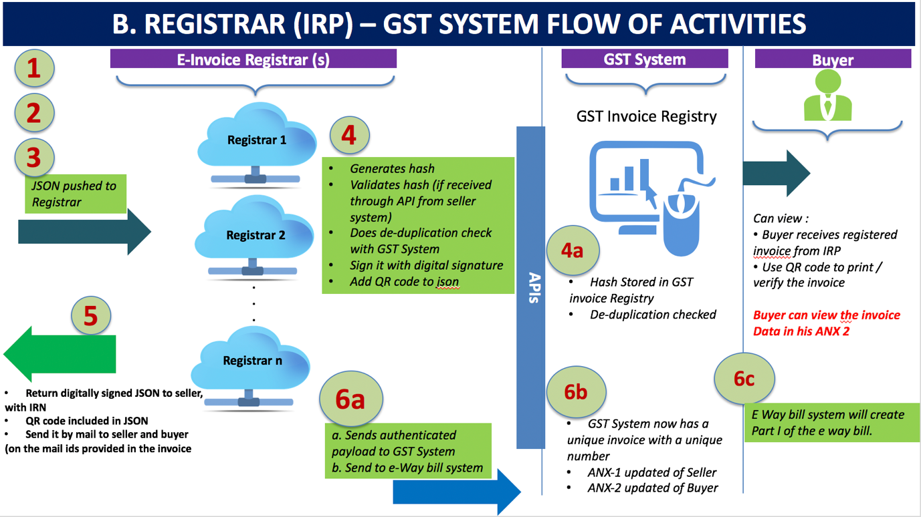**Part B: Flow from IRP to GST System/E-Way Bill System & Buyer**

The following diagram shows how e-Invoice data would be consumed by GST System for generation of e-way bill or populating relevant parts GST Returns, stated in Step-5 above.

**Step 5** **(a)** will be to share the signed e-invoice data along with IRN (same as that has been returned by the IRP to the seller) to the GST System as well as to E-Way Bill System.

**Step 5b** The GST System will update the ANX-1 of the seller and ANX-2 of the buyer, which in turn will determine liability and ITC.

**Step 5c** E-Way bill system will create Part-A of e-way bill using this data to which only vehicle number will have to be attached in Part-B of the e-way bill.

***Note 1****: The e-invoice standardized schema has mandatory and optional items. The e-invoice shall not be accepted in the GST System unless all the mandatory items are present. The optional items are to be used by the seller and buyer as per their business need to enforce their business obligations or relationships.*

***Note 2****: Seller may send his e-invoice for registration to more than one registrar. But the GST system and IRP will perform a de-duplication check with central registry to ensure that the IRN that is generated is unique for each invoice. Therefore, the IRP shall return ONLY ONE registered IRN for each invoice to the seller. In case of multiple registrars (more than one IRPs) only one IRP will return a valid IRN to the seller. Except one, all other IRPs will reject the request of registration.*

***Note 3****: The QR code will enable quick view, validation and access of the invoices from the GST system from hand held devices*.

**F. Direct Invoice Generation on IRP (Invoice Registration Portal)**

Many people think that e-invoice will be generated from government’s tax portal. This is a myth and invoices will continue to be generated using an Accounting or a billing software, keeping in view the varied need of item master, buyer master, UQC etc. along with sub-second response from IR Portal (IRP). Thus, direct creation/generation of e-invoice from GST portal or any other government portal is not envisaged/planned.

Small taxpayers can use one of the eight free accounting/billing software currently listed by GSTN. Also, GSTN will provide Offline Tool where data of an invoice, generated on paper can be entered which in turn will create JSON file for uploading on the IRP. Taxpayers can also use one of the commercially available accounting/billing software for this purpose. All accounting and billing software companies are being separately asked to adopt the e-invoice standard so that their users can generate the JSON from the software and upload the same on the IRP.

**G. Features of e-invoice system**

**The Format of Unique Invoice Reference Number (IRN)**:

The unique IRN will be based on the computation of hash of GSTIN of generator of document (invoice or credit note etc.), Year and Document number like invoice number. This hash will be as published in the e-invoice standard and unique for this combination. This way hash will always be the same irrespective of the registrar who processes it. The hash could also be generated by the taxpayers based on above algorithm. The providers of accounting and billing software are being separately asked to incorporate this feature in their product. One can pre-generate and print it on the invoice book, however, the same will **not make the invoice valid** unless it is registered on the portal along with invoice details.

***Note****: The hash algorithm that is to be used by the taxpayers has been specified in the e-invoice standard that is published.* ***The hash will be the IRN****.*

To ensure deduplication, the registrar will be required to send the hash to Central Registry of GST System to confirm whether the same has been reported already. In case it has been reported by another registrar (as and when more registrars – IRPs – are added) and the Central Registry already has the same IRN, then the registrar will reject the registration and inform the sender. Only unique invoices from a taxpayer will be accepted and registered by the registrar.

**Digital Signing by e-Invoice Registration Portal:** The invoice data will be uploaded on the IRP (Invoice Registration Portal), which will also generate the hash in order to verify it and then digitally sign it with the private key of the IRP. In case the taxpayer submits hash also along with invoice data, the same will be validated by IRN system. The IRP will sign the e-invoice along with hash and the e-invoice signed by the IRP will be a valid e-invoice and used by GST/E-Way bill system.

**QR Code**: The IRP will also generate a QR code containing the unique IRN (hash) along with some important parameters of invoice and digital signature so that it can be verified on the central portal as well as by an Offline App. This will be helpful for tax officers checking the invoice on the roadside where Internet may not be available all the time. The web user will get a printable form with all details including QR code. The QR code will consist of the following e-invoice parameters:

1. GSTIN of supplier
2. GSTIN of Recipient
3. Invoice number as given by Supplier
4. Date of generation of invoice
5. Invoice value (taxable value and gross tax)
6. Number of line items.
7. HSN Code of main item (the line item having highest taxable value)
8. Unique Invoice Reference Number (hash)

**The offline app** will be provided on the IRP for anyone to download to authenticate the QR code of the invoice offline and its basic details. However, to see the whole invoice, one will have to connect to the portal and verify and see the details online. The facility to download entire invoice will be provided to tax officers, the way it is currently available under E-way bill system.

***Note 4:*** *The facility of QR code verification will be made available only through the GST System and not the IRP. This is because the IRP will not have the mandate to store invoices for more than 24 hours. In order to achieve speed and efficiency, the IRP will be a lean and focused portal for providing invoice registration and verification service, IRN and the QR codes. Hence, storing of the invoices will not be a feature of the IRP.*

**Multiple Registrar for IRN System**: Multiple registrars (IRPs) will be put in place to ensure 24X7 operations without any break. To start with, NIC will be the first Registrar. Based on experience of the trial more registrars will be added.

**Standardization of Invoice**: A technical group constituted by the GST Council Secretariat has drafted standards for e-invoice after having industry consultation. The e-invoice schema and template, as approved by the GST Council, are available at <https://www.gstn.org/e-invoice/>.

**H. CREATION OF E-INVOICE**

**Modes for getting invoice registered**: Multiple modes will be made available so that taxpayer can use the best mode based on his/her need. The modes given below are envisaged at this stage under the proposed system for e-invoice, through the IRP (Invoice Registration Portal):

* 1. Web based,
  2. API based,
  3. SMS based,
  4. mobile app based,
  5. offline tool based and
  6. GSP based.

**API mode**: Using API mode, the big tax payers and accounting software providers can interface their systems and pull the IRN after passing the relevant invoice information in JSON format. API request will handle one invoice request at time to generate the IRN. This mode will also be used for bulk requirement (user can pass the request one after the other and get the IRN response within fraction of second) as well. The e-way bill system provides the same methodology.

**Printing of Invoice**

The taxpayer can continue to print his paper invoice as he is doing today including logo and other information. E-invoice schema only mandates what will be reported in electronic format to IRP.

**General Questions on e-invoice system**

|  |
| --- |
| **Generic questions on e-invoice** |
| 1. Will businesses now be required to generate e-invoices on the GST portal or the e-invoice portal or the IRN portal?    1. No.    2. Businesses will continue to generate e-invoices on their internal systems – whether ERP or their accounting / billing systems or any other application.    3. The e-invoicing mechanism only specifies the invoice schema and standard so as to be inter-operable amongst all accounting/billing software and all businesses. 2. Please clarify whether there the current e-invoice schema is for the invoice to be issued by Govt or has to be maintained in the IT system by the tax payer?    1. The invoice schema has to be maintained and invoices generated using this schema by the taxpayer himself.    2. The GST portal or Invoice Registration Portal (IRP) will NOT provide facility to generate invoices. IRP is only to report the invoice data.    3. The ERP or accounting billing software or any other software tool to generate e-invoice of the seller shall only generate invoices. 3. Will there be separate invoice formats required for Traders, Medical Shops, Professionals and Contractors?    1. No.    2. Same e-invoice schema will be used by all kinds of businesses. The schema has mandatory and non-mandatory fields. Mandatory field has to be filled by all taxpayers. Non-mandatory field is for the business to choose. It covers all most all business needs and specific sectors of business may choose to use those non-mandatory field which are needed by them or their eco-system. 4. How long will the e-invoice generated would be available at the Government portal?    1. It is again clarified that the e-invoice will not be generated at the GST portal.    2. It will be generated only at the seller’s system – whether ERP or the accounting/billing system/other software tools of the seller.    3. It will be uploaded into the GST ANX-1 only once it has been validated and registered by the invoice registration system.    4. After it has been validated and is available in the ANX-1, it will be visible to the counter party in his ANX 2.    5. Thereafter it will be visible and available for the entire financial year and archived.    6. As far as data on IRP is concerned, it will be kept there only for 24 hours. 5. While all businesses generate invoice at the same time, how will the server react?    1. The businesses will generate the invoice at their system and hence that will not impact the servers of IRP.    2. The capacity of the system at IRP shall be built so as to handle the envisaged loads of simultaneous upload based on data reported in GSTR1 for last two years.    3. Subsequently, multiple invoice registrars will be made available that will be able to distribute the load for invoice registration. 6. Is it possible to auto populate fields of the e-invoice based on credentials entered? That way it can minimize data entry errors.    1. Since the invoice generation is to happen at the business end, this can be built into the ERP or invoicing system of the seller. Most of such software provide this facility in the name of item master, supplier master, buyer master etc. 7. Will it be possible to add transporter details as well?    1. No.    2. The transporter details must be entered in the E-Way bill system only. |
| Contents of e-invoice |
| 1. There are certain fields today which are optional and some mandatory. How are these to be used?    1. The mandatory fields are those that MUST be there for an invoice to be valid under e-Invoice Standard.    2. The optional ones are those that may be needed for the specific business needs of the seller/business. These have been incorporated in the schema based on current business practices in India.    3. The registration of an e-invoice will only be possible once it has ALL the mandatory fields uploaded into the Invoice registration Portal (IRP).    4. A mandatory field not having any value can be reported with NIL. 2. What is the maximum Number of line items supported by e-invoice?    1. The maximum number of line items per e-invoice is 100. 3. Does the e-invoice schema provide the maximum length of the various fields in the schema?    1. Yes.    2. Each field specification has been provided with the type of characters that are to be entered and its length as well. 4. What will be the threshold requirement for E-Invoicing applicability?    1. This will be notified by the Government at the time of rollout.    2. As already mentioned above, the rollout of the e-invoice mechanism will be in phases. 5. Will the e-invoice have columns to show invoice currency?    1. Yes, the seller can display the currency. Default will be INR. 6. Whether the IRN is to be captured in the Supplier’s ERP?    1. The IRN (hash) will be generated by GST System using GSTIN of supplier or document creator, financial year and the unique serial number of the document/invoice. The IRN can also be generated by the seller.    2. The serial number of invoice will be unique for a GSTIN for a Fin Year and the same has to be captured by Supplier’s ERP.    3. Supplier has to keep the IRN against each of its invoice. It will be advisable to keep the same in the ERP as invoice without IRN will not be a legal document. 7. Whether e-invoice generated is also required to be signed again by the taxpayer?    1. Not mandatory. However, if a signed e-invoice is sent to IRP, the same will be accepted.    2. The e-invoice will be digitally signed by the IRP after it has been validated. The signed e-invoice along with QR code will be shared with creator of document as well as the recipient.    3. Once it is registered, it will not be required to be signed by anyone else. 8. Whether the facility of adding discount amount at line item-level would be mandatory in nature?    1. The e-invoice has a provision for capturing discount at line item level.    2. The discounting at line item level is to be mentioned only when and if it is applicable in the particular transaction. 9. Can the seller place their LOGO in the e-Invoice Template?    1. There will NOT be a place holder provided in the e-invoice schema for the company logo.    2. This is for the software company to provide in the billing/accounting software so that it can be printed on his invoice using his printer. However, the Logo will not be sent to IRP. In other words, it will not be part of JSON file to be uploaded on the IRP. 10. There should be a space provided for the QR code to be placed.     1. The QR code will be provided to the seller once he uploads the invoice into the Invoice Registration system and the same is registered there.     2. Seller can at his option may print the same on Invoice. 11. Will we be able to provide the address and bill-to party and PAN details in the e-invoice?     1. Yes.     2. It will be possible to provide all these details in the placeholders provided in the schema. 12. Would the Supplier be allowed to issue his own invoice and if yes, will the Invoice number and IRN be required to be mentioned?     1. Yes, the supplier will issue his own system’s invoice, in the standard e-invoice schema that has been published. Invoice number is a mandatory item under GST and hence for e-invoice.     2. IRN (Hash) can be provided after the e-invoice has been successfully reported to the IRP. E-Invoice will be valid only if it has IRN. 13. The current e-invoice template provides for total discount for all the products or services. Will this be possible in the e-invoice?     1. Yes.     2. There is a mechanism and placeholders to provide discounting on item level as well as total discounts on the invoice value. 14. Will there be an option for linking multiple invoices in case of debit note/ credit note?     1. Yes, it will be allowed to link the credit/debit notes as hitherto fore. 15. Will the e-invoice schema cater to reverse charge mechanism?     1. Yes.     2. E-invoice system has a reverse charge mechanism reporting as well. |
| Method of Reporting e-Invoice to GST System |
| 1. In addition to the above, we understand that electronic invoice which will be uploaded on GST portal will be authenticated and IRN will be allocated for each e-invoices generated.    1. Yes, the e-invoice will be authenticated with the digital signature of the IRP (invoice registration portal).    2. IRN (Invoice Reference Number) will be the hash generated by the IRP.    3. The registered invoice will be valid to be used by the business. 2. Will it be possible for bulk uploading of invoices for e-invoicing as well?    1. Invoices have to be uploaded on IRP one at a time.    2. The IRP will be able to handle a large sequence of invoices for registration and validate them. Essentially bulk upload will be required by large taxpayers who generate large number of invoices. Their ERP or accounting system will have to be designed in such a way that it makes request one by one. For the user, it will not make any difference. 3. Will the requirement for such invoices to be authenticated by the supplier using a digital signature/signature be done away with?    1. The seller will need to upload the e-invoice into the Invoice Registration Portal.    2. The signing of e-invoice by seller is not mandatory. 4. Will there be a time limit for e-invoice uploading for registration?    1. Yes, that will be notified by the Government. Without registration of e-invoice the same will not be valid. Required changes will be made in the law.    2. Once uploaded to the invoice registration portal (IRP), it will be registered immediately, on real-time basis. 5. Will it be possible to allow invoices that are registered on invoice registration system/portal to be downloaded and/or saved on handheld devices?    1. Yes.    2. IRP System after registering the invoice, will share back digitally signed e-invoice for record of supplier. It will also be sent to the email address of recipient provided in the e-invoice. 6. Will it be possible to print the e-invoice?    1. Yes.    2. It will be possible for both the seller as well as the buyer to print the invoice, using the QR code as well as signed e-invoice returned by the Invoice Registration Portal (IRP). |
| Amendment/cancellation of e-invoice |
| 1. Whether e-invoices generated through GST system can be partially/fully cancelled?    1. E-Invoice can’t be partially cancelled. It has to be fully cancelled.    2. The e-invoice mechanism enables invoices to be cancelled. This will have to be reported to IRN within 24 hours. Any cancellation after 24hrs could not be possible on IRN, however one can manually cancel the same on GST portal before filing the returns. 2. How would amendments be allowed in e-invoice?    1. Amendments to the e-invoice are allowed on GST portal as per provisions of GST law. All amendments to the e-invoice will be done on GST portal only. |
| Relationship with e-way bill |
| 1. With the introduction of e-invoices, what are the documents need to be carried during transit of goods?    1. For transportation of goods, the e-way bill will continue to be mandatory, based on invoice value guidelines, as hitherto fore. This aspect will be notified by the Government when this mechanism will be notified. |
| Export/Import |
| 1. Please clarify whether exports would require e-invoice compliance.    1. Yes.    2. The e-invoice schema also caters to the export invoices as well. The e-invoice schema is based on most common standard, this will help buyer’s system to read the e-invoice. 2. Does the e-invoice allow the declaration of export invoices/ zero rated supplies?    1. Yes.    2. It allows the declaration of export invoices / zero rated supplies. |
| **Others** |
| 1. What will be the workflow of the end to end e-invoice mechanism?    1. The end to end workflow will be provided by at the time of rollout of the e-invoice system. 2. Will the industry be provided sufficient time for preparation?    1. Yes.    2. The e-invoice mechanism is expected to be rolled out in phases from 01st Jan 2020 on voluntary basis.    3. Initially, the e-invoice mechanism will be allowed for tax payers above a certain turnover or above a certain invoice value or also to volunteers.    4. Subsequently, it will be enabled for all tax payers in a phased step-wise manner.    5. Details of these will be published subsequently. |